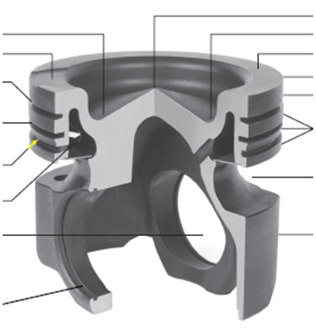
Which of the following features would be required in an aluminum alloy, trunk type piston when used in a commercial diesel engine application?
full floating wrist pin
ring groove insert (Ni-Resist)
tin plating
chromed pin boss

A trunk style piston is a (single, two, three) piece design.
Piston absorbs up to ___________rejected heat from cylinder gases.
Cam Ground is when an aluminum piston is ______________________ when cold to allow for ________________________ when the piston is warming up.
A _____________________ designed by _______________ is currently used in most OEM engines today.

Monotherm/Mahle vs Alluminum True or False
Monotherm is heavier___________________
Monotherm is stronger___________________
Monotherm has less piston slap__________________
Monotherm is more currently used__________________
Monotherm is the beez kneez___________________
Monotherm needs wrist pin bore bushings________________
Monotherm has a larger headland volume for better clearances________________
Monotherm is more vulnerable to cylinder pressures__________________
Monotherm improves emissions_________________
Monotherm has a composite metal version know as _______________also a Mahle design.
Articulating pistons have 2 styles________________________and__________________________.
Articulating pistons have 2 parts ________________________and__________________________.
Articulating pistons are _____________than aluminum and Mahle pistons, so other powertrain components have to be ___________________________.
When you have a lighter piston then __________________ RPMS are possible.
Most common piston crown design is _____________________
What is another way of describing the toroidal recess in a Mexican hat type piston?
crater
piston leading edge
skirt wall assembly
cone
Minimal toroidal recess or low turbulence piston crowns are known as________________

Label
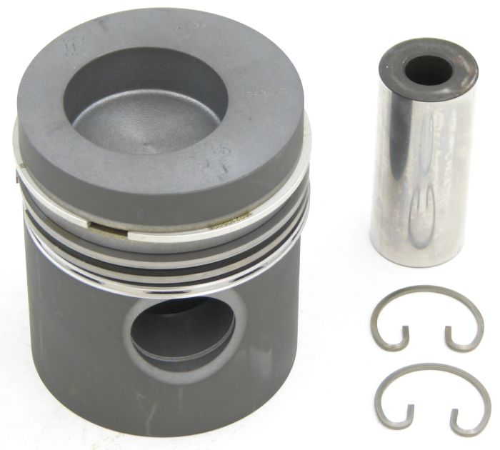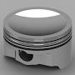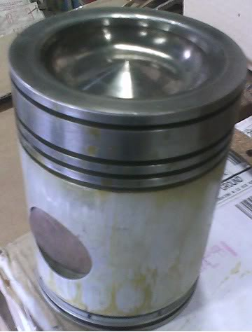
_________________________ ________________________ _____________________
What is the most current piston cooling method?___________________________
To little clearance between the cylinder and piston can cause__________________________
Other possible liner failures are._________________ and ______________________.
Viewed from the front, a Cummins ISX rotates clockwise. On which side are the piston major thrust faces be located? Remember left/right is always from the drivers Point of View.
front
left side
right side
Rear
Which side is the Antithrust as viewed by driver._______________________
Typical ring layout is ______ compression and _______ oil ring
The major sealing force of compression rings is ___________________.
Label with shape and (compression or scraper)
_______________ _____________ ________________ _____________ ______________
_______________ _____________ ________________ _____________ ______________
What ring joint best seals cylinder gases?_____________________
The oil/scraper ring lubricates on the ________________and scrapes on the __________________.
Rings are normally stamped with “Top Side” or a ___________ to label what side goes up.
What links the connecting rod to the piston?_________________________
Connecting rods have caps that are separated by _________________ or _________________.
Cracked connecting rods must be __________________________________________. If any damage is done to a cracked connecting rod the rod must be ___________________.
Cracked connecting rods insure perfect ______________ between rod and cap.
Crankshaft Labeling
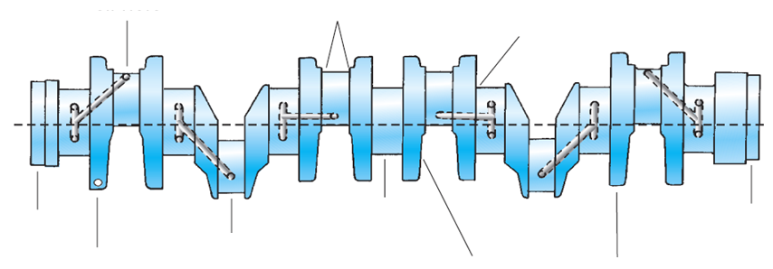
How is a crankshaft suspended in a bearing?_________________________
A Crankshaft has been damaged by a spun bearing. What would be the recommended OEM repair? Replace Resurface Welding Continue operation if damage is less than .004 in
What is plastigage used for measuring?
friction bearing clearance
big end side play
flywheel runout
crankshaft endplay
Excessive end play of crankshaft is fixed by the use of oversized ____________________.
Replace Viscous Vibration Dampers….____________________ or ___________________________.
Replace solid Vibration Dampers….__________________________________________________.
Ring Gears are fitted to the flywheel through_________________________________________.

